Things to note when completing the Questionnaires:

Palabora Registration Questionnaire:
- Company name + Names + Surnames must be in UPPERCASE
- Email addresses must be in LOWERCASE
- No spaces in contact numbers
- Important! Section 8 for CURRENT MAJOR CUSTOMERS must also comply with rules as per 1 – 3 above.

Palabora Banking Data:
- No spaces in bank account number
- 1.3 Account Holder Name: No special characters, e.g. ( ) & # % - *

Suppliers are allowed only 1 attachment at a time.
E.g. If your company has 5 directors, please scan 5 IDs in one go and attached 1 file. If done incorrectly and the response is submitted, you in in status “Pending Approval” and changes can only be made once you are in status “Registered”, which can take a long period of time, depending on how fast all approvers execute their part.

Trust this clarifies and will ensure a smooth process for you !

Supplier receives invitation from Palabora to register on the SAP Ariba Network as a supplier
Click on the link “Click here”

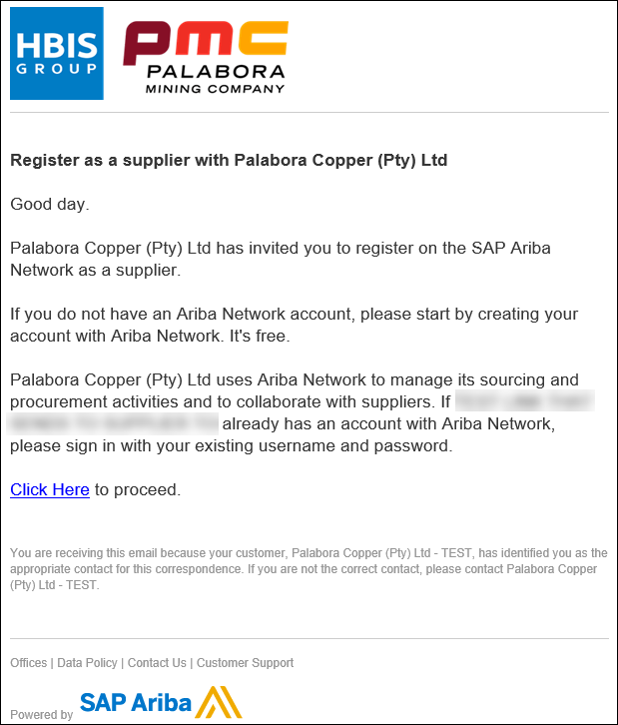

Supplier must “Sign up”

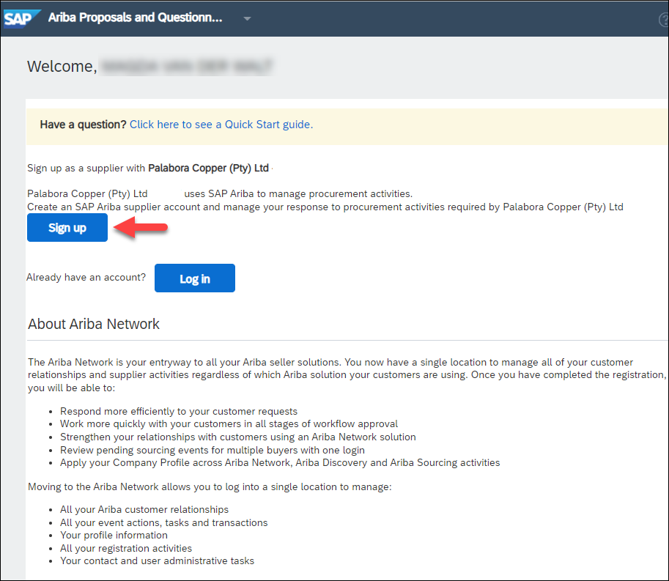

Important: Save your Username + Password to use for future login to your account

If you need to make changes to the Palabora Questionnaires, namely Palabora Registration Questionnaire and/or Palabora Banking Data, proceed as follows:

Click Ariba Network Supplier to sign in
Login with Username and Password

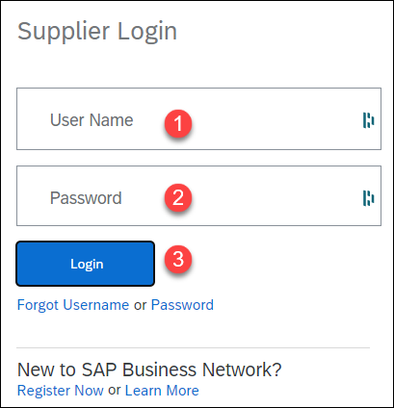

Dashboard

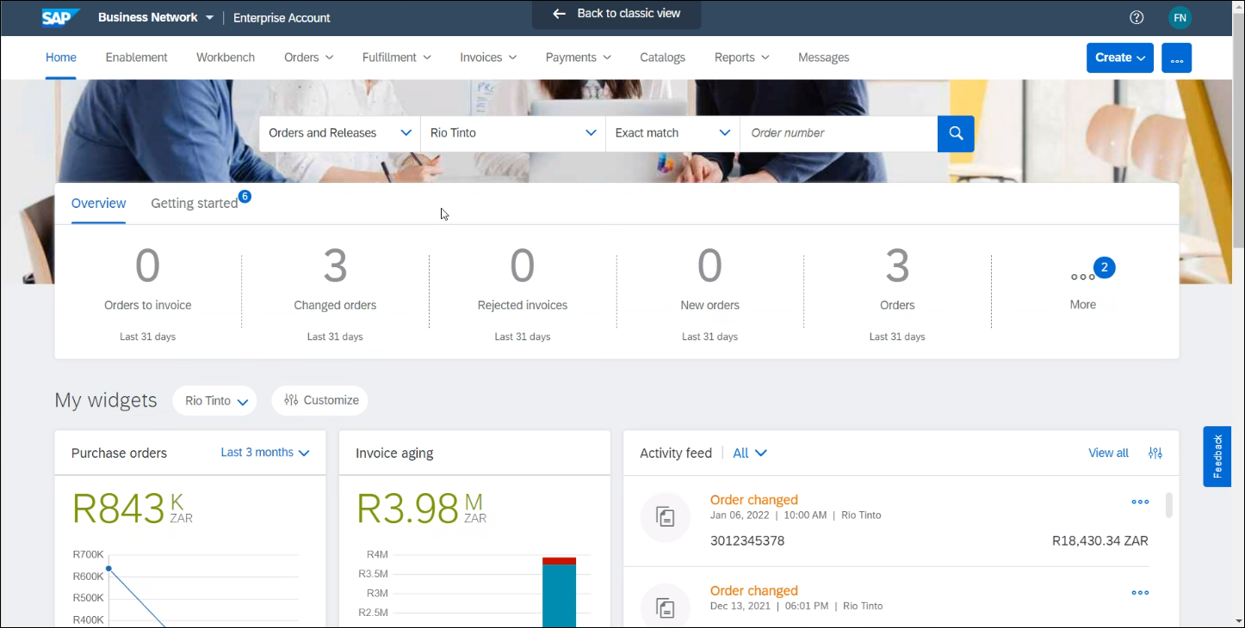

Drop down on Business Network – Select Ariba Proposals & questionnaires

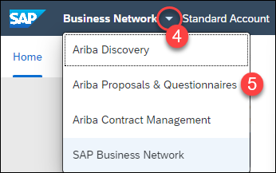

Open the Questionnaire you wish to change

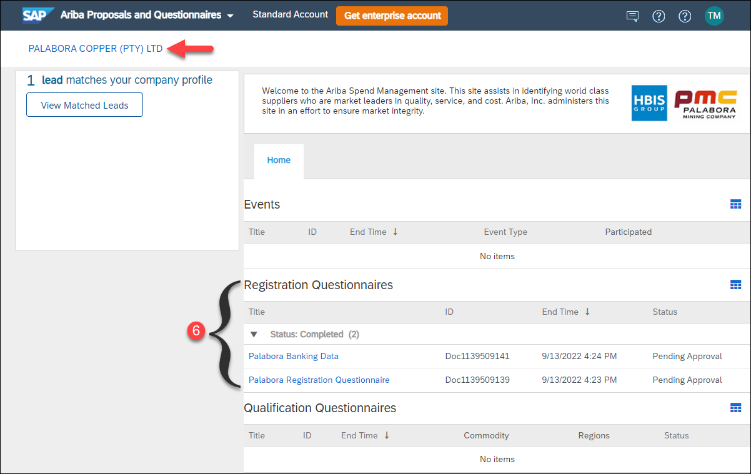

Click “Revise Response” and make changes where required

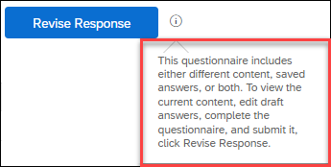

Important: When done, click
Note: Status is in PENDING APPROVAL, and you won’t be able to make any further changes to the questionnaire until Palabora Copper approvers approved and your status is REGISTERED

